1. Extract the zip/rar file locally.
2. Goto the location and copy the .addin file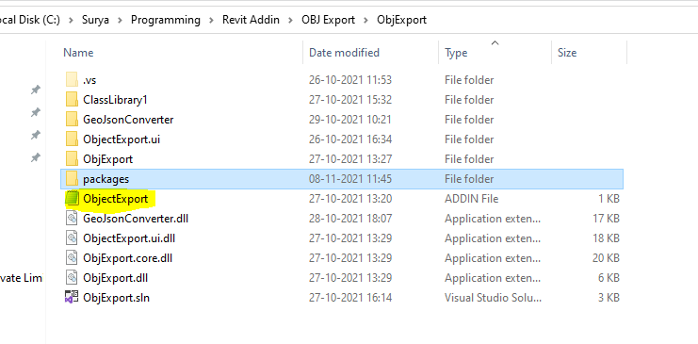
3. Paste the addin file in this location with respect to the Revit version in which you want to access the addin.
4. Goto the location where you’ve extracted the Zip file and copy the path of the ObjExport.dll file pressing “Shift” and right clicking on the ObjExport.dll file. 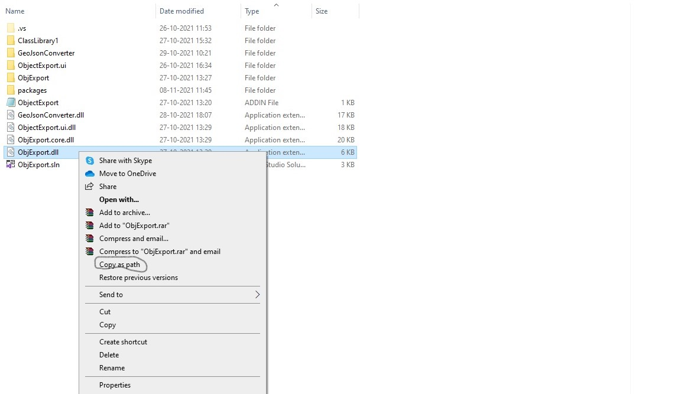
5. Open the addin file in the location where you copied in the step 3 and paste the location instead of the location mentioned in the addin file.

